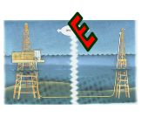
ELYXXON ENGINEERING
AND CONSTRUCTION
LIMITED

COMPANY PROFILE AND RESUME

CORPORATE OFFICE/FABRICATION YARD:
ELYXXON YARD,
Km 15, Port International Airport Road,
Opposite Big Treat Plaza, Rumuodomaya,
Port Harcourt.
Tel: 0804-798267, 0803-573-1483, 0802-312-5057, 0805-487-3093,
Fax: 084-231-719
E-mail: info@elyxxom.com
elyxxon@yahoo.com

ELYXXON ENGINEERING AND CONSTRUCTION LIMITED is an incorporated organization, that provides the following technical support services to the oil and gas industry.

Environmental, Process, and Thermal
engineering services,

Mechanical Engineering Design and Construction,

Fabrication, supply and installation of
process equipment, and Instrumentation.

Civil Engineering Construction

Inspection, and Corrosion Engineering services.

ELYXXON ENGINEERING is based in Port Harcourt, Nigeria, and employs about 24 people in its oil and gas service operations, inclusive of non permanent staff.

ELYXXON ENGINEERING aspires to be one of the fastest growing firms among the indigenous oil and gas service organization,

ELYXXON ENGINEERING provides project management, engineering, procurement and construction services for the oil & gas industry, power plants, buildings, general civil works, offshore light industry, etc.

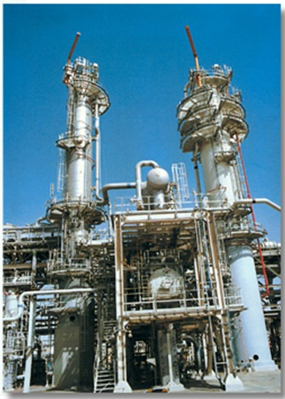

- MECHANICAL ENGINEERING WORKS
- Petrochemical plants and refineries (gas treatment plants, gathering centers and pumping stations,

- bulk crude handling and storage facilities, prefabrication of piping spools, pipe supports and structural assemblies), oil loading and off-loading terminals, fabrication of platforms for off-shore facilities
- Heavy and light industrial plants

- PIPELINES
- Water, oil and gas

- MAINTENANCE OF MECHANICAL INSTALLATION & STRUCTURES
- Oil refineries, petrochemical plants, offshore structures

Other Services Includes;

Turnkey construction of Onshore and Offshore Oil & Gas projects including Jetties, Storage Tanks, Columns, Evaporators, Heaters, Packaged Equipment, Pipe coating, Pipe laying, and related items.

• Pilot plant studies, from initial feasibility study to full turnkey plant installation + Planned maintenance

• Project management

• Installation + Commissioning + Operator training

• Plant / Process refurbishment and overhaul + Full technical support and after sales service.

- BUILDING & CIVIL ENGINEERING WORKS

- Construction of Jetties, Power plants, Housing and high quality buildings including hotels, hospitals and educational institutions.
- Construction of Roads, highways, drainages, etc

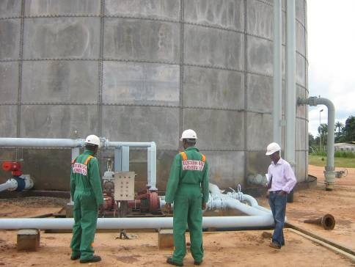
• MECHANICAL SERVICES

- Sand-blasting and painting of tanks and steel structures
- Pipe work (isometric) design and construction

- Oil gathering - flow stations • Gas gathering stations • Oil & gas pipelines,
- • Gas/Oil Separation plants • Oil & gas phase separation • Oil & gas dehydration
- Incinerators
De-sanding / Desludging of 25,000 barrel Crude Oil storage Tank, at Addax Izombe Flow Station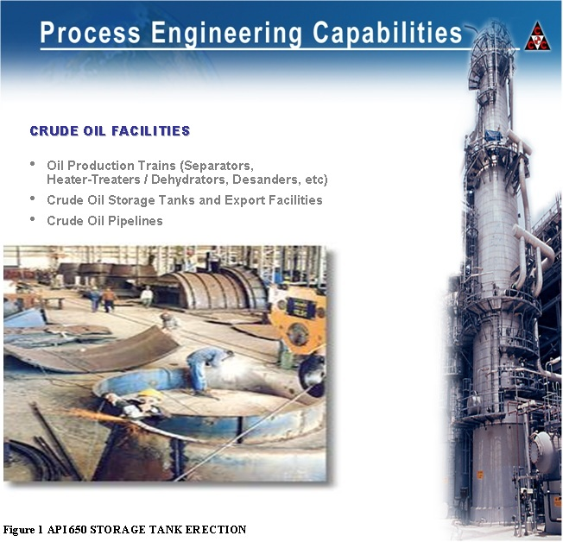
- EPC Activities:
- Process
- Mechanical
- Piping
- Electrical & Instrumentation
- Civil / Structural
- Facilities Management

- Gas compression systems
- Flare gas knockout vessels
- Gas transmission pipelines
- Flare auto-ignition system
- Flare stacks

GAS HANDLING AND TREATMENT FACILITIES

- MECHANICAL ENGINEERING WORKS

- Prefabrication of piping spools, pipe supports and structural assemblies), oil loading and off-loading terminals, fabrication of platforms for off-shore facilities
- Heavy and light industrial plants

- PIPELINES
- Water, oil and gas

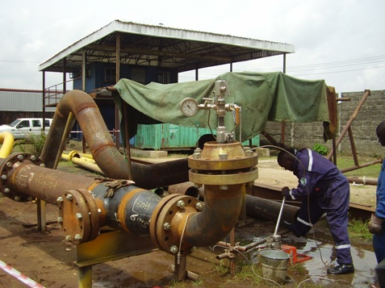

Hydro-Testing of Pre-fabricated Piping Spools at ELYXXON Fabrication Yard

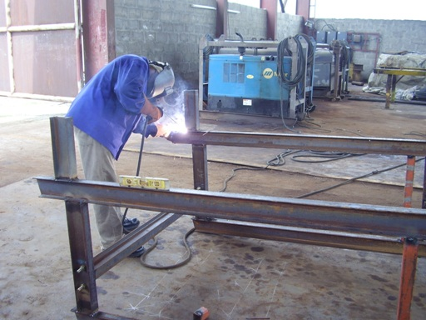

Above: Steel Structural Fabrication of Canopy structures for Addax Petroleum

Below: Commissioning of line heater Auto Ignition system at Addax Izombe Flow
Station

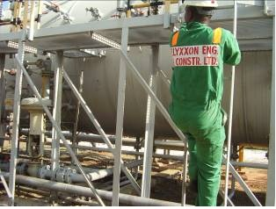

Name: Engr. Felix Nwokorie (M.Sc., MNSE)

Position: Managing Director
- Qualification: B.Eng., Mechanical Engineering,
M.Sc., Design and Production Engineering,
Member Nigerian Society of Engineers.

- Specialization : Process Equipment Engineering,
Thermo-fluid Engineering,
Mechanical Design / Construction
- Working Experience: SOAS Nig Plc 1990 – 1991

NNPC Gas Division 1991 – 1992
PZ Industries Plc, Lagos, 1992 – 1994
Boskel Nig. Ltd. 1994 – 1998
Jurak Oil Services Ltd. 1998 – 1999
Elyxxon Engineering, 1999-present
Consultant to Hamacorp Oil and
Gas Exploration Ltd.

Name: Mr. Samuel Asiununkagh Etuk-Akpan

Position: Executive Director, Technical

Qualification: B. Sc. Mechanical Engineering

Specialization: Industrial/Env. Engineering.
Working Experience: Nigerian Dynamics Ltd Benin 1997-1998, HAZCON Ltd 1998 – 2011
Elyxxon Engineering And Construction Limited (2011 Till Date).

Name: Mr. Akeem Olatunji

Position: Project Engineer

Qualification: B. Eng Mechanical Engineering

Specialization: Mechanical Construction
Working Experience: Standard Construction Nig Ltd, 1989 – 1993; JGC Nig. Ltd,
1993 – 1994
Walter Smith Petromann Ltd. 1994 – 1999, Elyxxon Eng. & Const.
Ltd. 1999-present.

Name: Mr. Uzo Ngoka

Position: Instruments / Control Systems Consultant

Qualification: B. Eng. Electrical Electronics Engineering
M. Sc., Control System Design
Specialization: Industrial/Control System Engineering.
Working Experience: Nigerian Dynamics Ltd Benin 1993-1995,
Summit Systems Ltd, 1995 – 2000
Elyxxon Engineering And Construction Limited (2001 Till Date).

TOTAL (Inclusive off Non Permanent Staff) 24

- Elyxxon Engineering Safety & Controls Department monitors and supports all our projects sites.
- Elyxxon Engineering effectively implements a Standardized Project Safety Program Structure throughout all our Projects.
- Elyxxon Engineering conforms to certification ISO 14001 Environmental Management Systems.
- Our existing projects worked a total of 1.6 Million Man-hours without a Lost Time Accident.

Health
Safety

Environment
Zero Accidents

Elyxxon Engineering is committed to the principle of providing all their Clients with quality services/products, ensuring the achievement of the agreed specifications.
For many years Elyxxon Engineering has been operating a Quality System to ISO 9001, and ISO 9002. By so doing, we intend to remain a market leader by pursuing a program of continuous quality improvement.

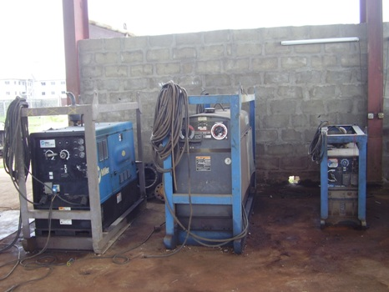

Elyxxon Engineering owns and operates an engineering workshop/Fabrication yard in Port Harcourt.

MATERIALS CAPABILITY

PIPE
The following pipe materials can be welded in our firm:

ASTM A 106 GRADE B Carbon Steel
ASTM A 335 GRADE P5 Chrome Molybdenum Steel
ASTM A 335 GRADE P11 Chrome Molybdenum Steel
ASTM A 333 GRADE 6 Carbon Steel Low Temperature
ASMT SB 165 Model
API 5L X 52 Carbon Steel
API 5L X 60 Carbon Steel
ASTM A 527 GRADE 50/42 Carbon Steel
ASTM A 53 Carbon Steel
API 5L GRADE B Carbon Steel
ASTM A 312 GRADES 316L, 304L, 321Austenitic Stainless Steel

STRUCTURAL STEEL

The following steel materials can be welded in our shop:

ASTM A 36 - ASTM A 283 GRADE C - ASTM A 516 GRADE 65 -
ASTM A 572 GRADE 50/42 - ASTM A 285 GRADE C

Our Welding Engineering and Quality Control experts are capable of developing welding procedures to deal with any weldable material in the construction industry, including (TIG/MIG welding, SMAW welding, etc ).

PROJECT EXPERIENCE

S/N | CLIENT | LOCATION | PROJECT TITLE | DURATION
1 | NNPC Refinery Complex  (Main Contractor: IPCO WA LTD) | Eleme, Port Harcourt | Sand blasting and painting of Tanks and piping | 6 months  June 1999
2 | NNPC Eleme Petrocemical Complex(Main Contractor: Jurak oil Ltd) | Eleme, Port Harcourt | (a) Rehabilitation of Teal Building and Structures  (Polypropylene Plant)  (b) Sand blasting and painting of Teal plant  vessels and piping  support | April – Nov 2001
3 | NNPC Refinery Complex  (Main Contractor: GLOFELA LTD) | Eleme, Port Harcourt | Construction of Drainage around the Pump House Area | Feb-Mar. 2002
4 | NNPC Eleme Petrocemical Complex | Eleme, Port Harcourt | Procurement of Various TIG Welding consumables (for Olefins Plant Furnace Tube) | 2002-2004
5 | NAFCON Complex  (Main Contractor: KELLOG B & R Ltd) | Onne | Procurement and Construction of 6-inch stainless steel pipe drainage | Sept 2001
6 | Decon Energy Serv Ltd | Trans Amadi, Port Harcourt | Design, and construction of office block and Warehouse | June –Nov. 2004
7 | Nigerian Bottling Company PLC(Main Contractor: WASOLA Ltd) | Trans Amadi, Port Harcourt | Design, construction, and erection of 4-inch SCH 150 process pipeline (For bottling plant) | Sept.-Nov. 2004
8 | Shell Petroleum Dev. Co. Ltd(Main Contractor: Packlinc Ltd) | SPDC Obigbo Manifold, Kom Kom | Construction and Erection of Enhanced Manifold Caging | June-Sept. 2005
9 | Shell Petroleum Dev. Co. Ltd(Main Contractor: Jurak oil Ltd) | Imo River 2 Flow Station | Design, Construction, and Installation of 16-inch Smokeless Flare Stack | Aug-Dec. 2003
10 | Nigeria Agip Oil. Co. Ltd (Main Contractor: Jurak oil Ltd) | Oshie Flow Station | Design, Construction, and Installation of Twin 30-inch Smokeless Flare, Auto Ignition System and Bondwall | 2000-2002
11 | Addax Petroleum Development Nigeria Limited | Addax OML 124 | Fabrication of Pipe clamp of various sizes,(for oil leak containment) | 2004-2005
12 | Addax Petroleum Development Nigeria Limited | Izombe Flow Station | Rehabilitation of Line Heater Auto Ignition System | 2007
13 | Addax Petroleum Development Nigeria Limited | Ossu Manifold | Ossu Wells Sand Management OML-124 | Dec 07-Mar 2008
14 | Addax Petroleum Development Nigeria Limited | Ossu Manifold | Sand Management In OML-124 | April-June, 2008
15 | Addax Petroleum Development Nigeria Limited | Izombe Flow Station | De-sanding and De-sludging of Tank 7000 barrel crude oil tank | July, 2008
16 | Addax Petroleum Development Nigeria Limited | Izombe Flow Station | De-sanding and De-sludging of Tank 25000 barrel crude oil tank | Oct, 2008
17 | Addax Petroleum Development Nigeria Limited | Izombe Flow Station | Rehabilitation of Auto Ignition System on the Flare Stack | Ongoing
18 | Nigeria Agip Oil. Co. Ltd (Main Contractor: Glofela Ltd) | Bayelsa Community Ukparatubu | Construction of Classroom blocks | 2007
19 | Shell Petroleum Development Nigeria Limited (Main Contractor; Paxcy & Horsley Ltd) | Obigbo Flow Station  { Field Office Complex) | Installation of Portakabins, Hard Stand & Land-scapping. | April-Sept 2010
20 | Addax Petroleum Development Nigeria Limited | Izombe Flow Station | Servicing and repairs of Flame/Flashback Arrestors on Crude Oil Production Vessels | Sept/Nov 2009
 | Addax Petroleum Development Nigeria Limited | OML 124 | Design/Installation of Solar Powered System and Street Lighting | June- Sept 2010
21 | Nigeran Agip Oil Company Limited  (Main Vendor: Kronos Int’l) | Tebidaba Flow Station | Rehabilitation of Flare Stack; (including Design, fabrication, installation and commissioning of a new flare stack, together with ignition system) | June-Deptember 2011
22 | Addax Petroleum Development Nigeria Limited | Izombe Flow Station | Extension of Power Supply to Gate II | Oct-nov 2011
23 | Addax Petroleum Development Nigeria Limited | OML 124 | Instllation of Citadel fencing around the Ossu Manifold | Dec2011-Feb2012
24 | Imo State Government,  Federal Republic Of Nigeria | Owerri | Electrification of Housing Area F, New Owerri | Sept-Dec, 2009

